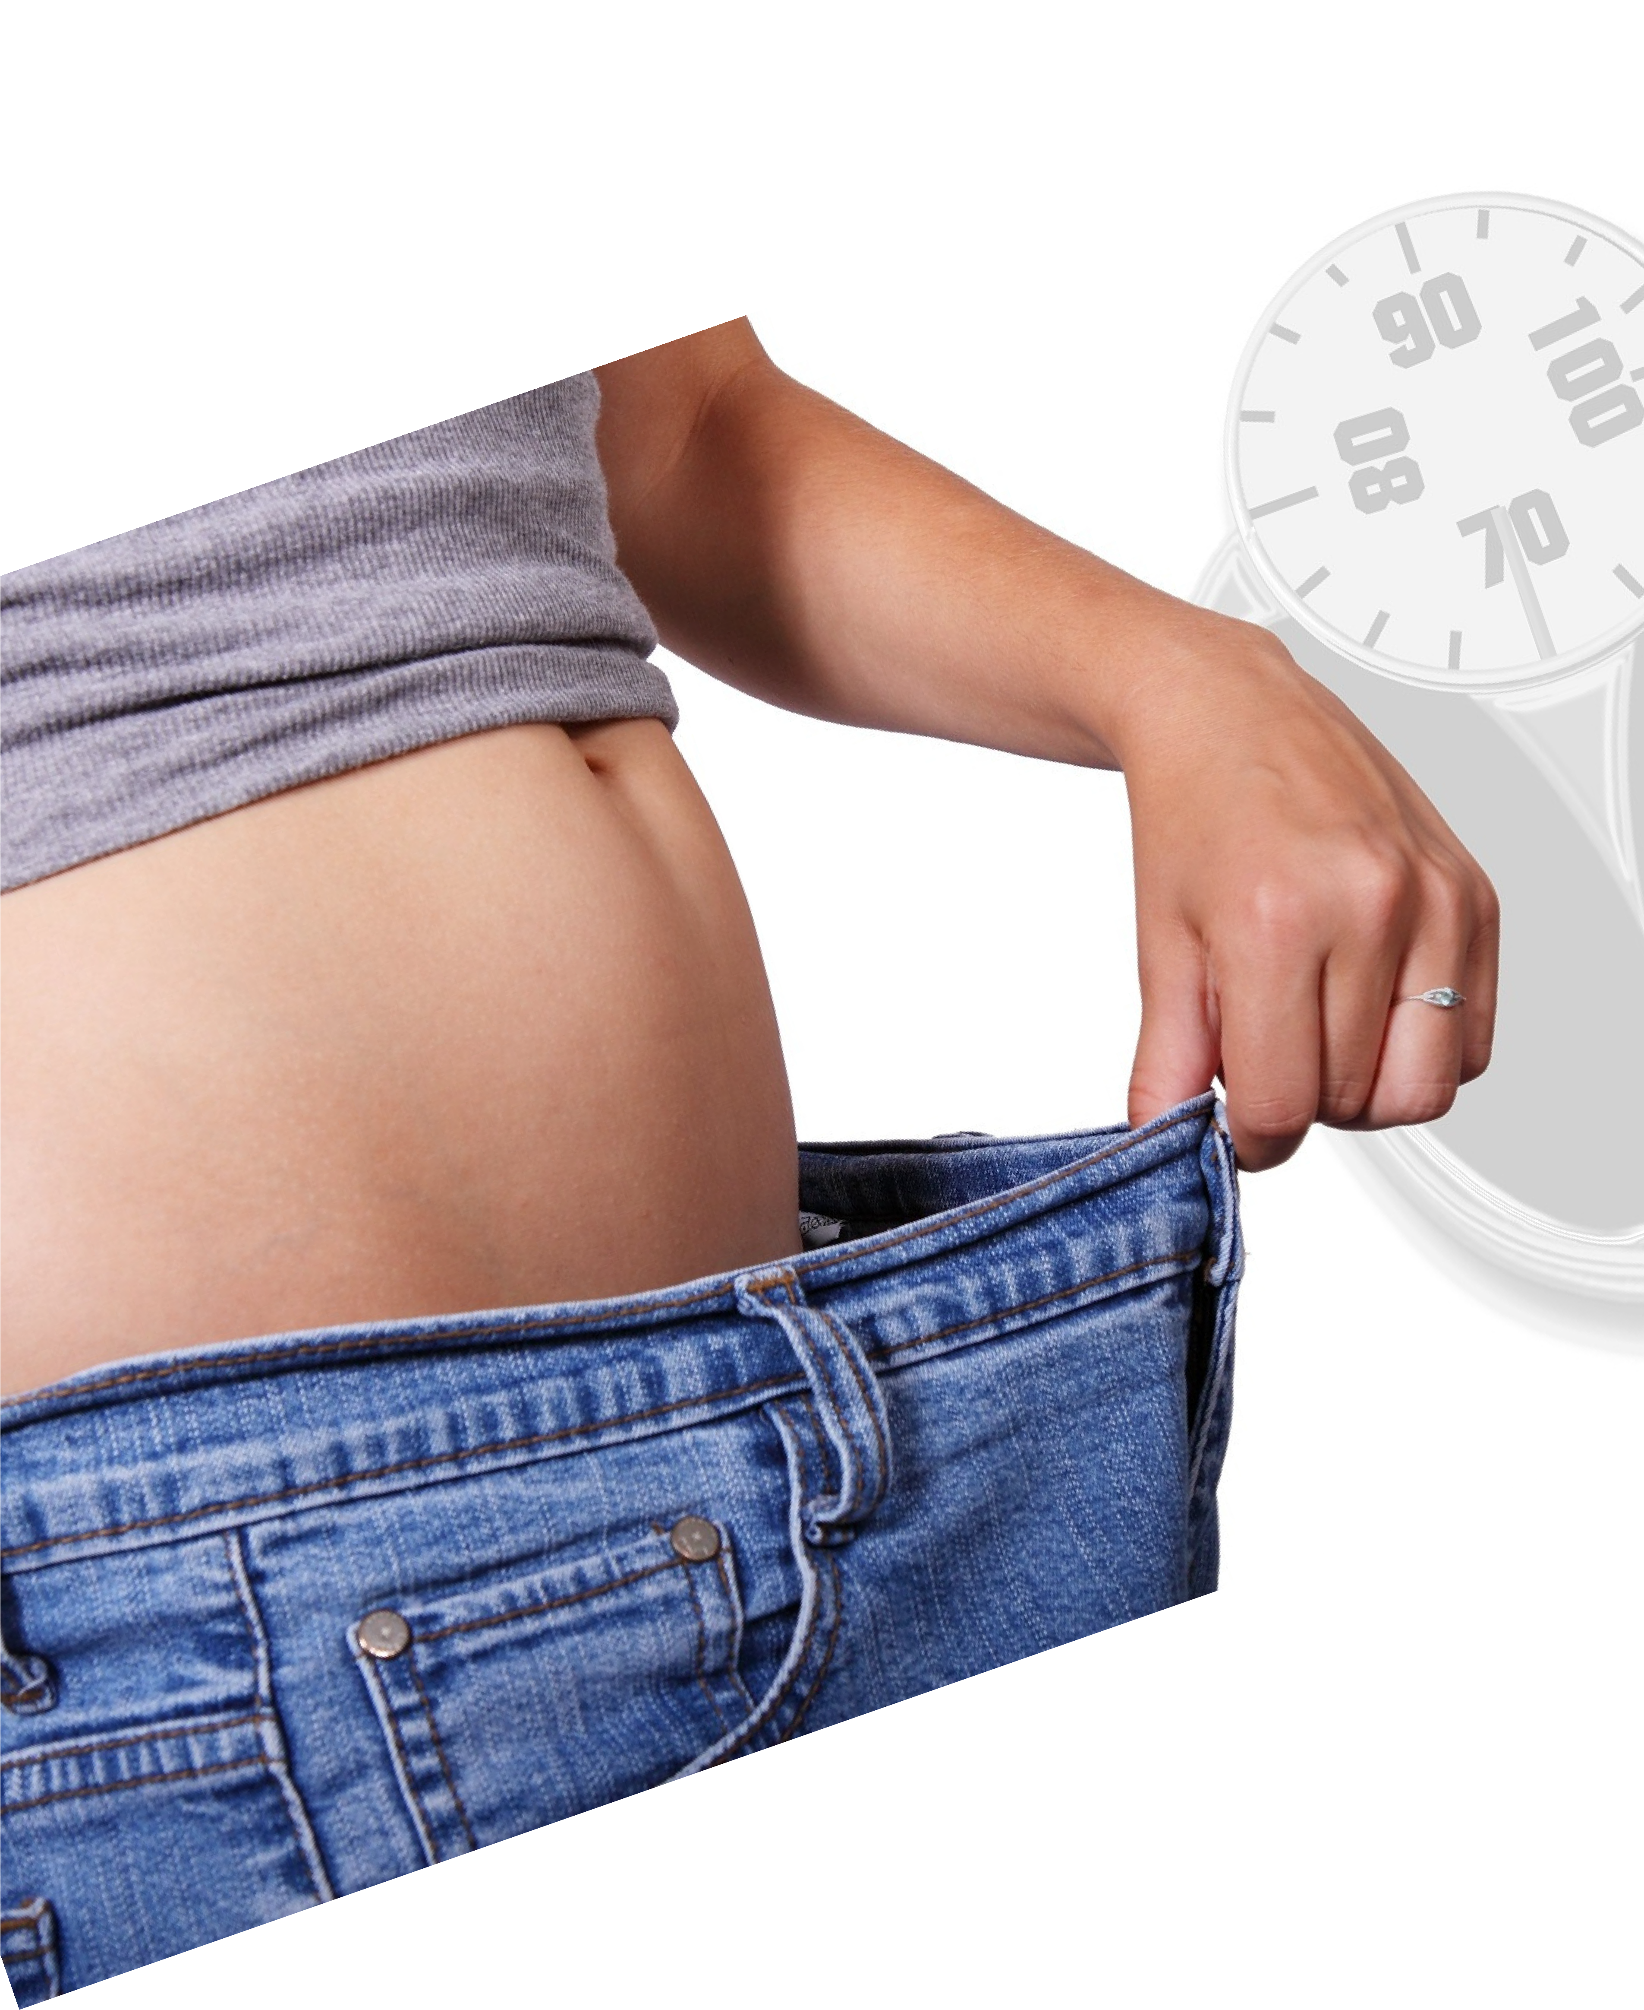
5 PROVEN AND SIMPLE WEIGHT LOSS HACKS
SIMPLE PROVEN TRICKS FOR SIGNIFICANT WEIGHT LOSS

Report By
Dr. Jo Rose

Thank you for opting in to get this valuable resource that I have used with countless people to jump start their weight loss.

In this free guide you will learn:

- How adding this one inexpensive thing to your f irst meal can help you lose 7 pounds in 90 days!

- How changing the time of day that you eat can help you lose 2 pounds more in a week!

- How making this one change will make you eat 12 % less, without even changing what you are eating!

- How adding this one ingredient to your meals will activate your fat burning power and help you lose 5 pounds in 12 weeks!
- How to demolish hunger cravings by this one l i ttle action and will result in eating 300 calories less per day!

Read on to discover these 5 simple tricks.

CHIA SEEDS
ADDING THEM TO YOUR FIRST MEAL CAN HELP YOU LOSE 7 POUNDS IN 90 DAYS!

Chia seeds are used to grow chia pets, you’ ve seen them advertised on TV. But I don’ t want you to grow a pet, I want you to add some to your diet.

An amazing study was reported in the Journal of Nutrition research and practice: Participants were divided into three groups
Group 1 was given yogurt for breakfast
Group 2 was given yogurt and 1 ½ teaspoons of Chia seeds Group 3 was given yogurt and 3 teaspoons of Chia seeds
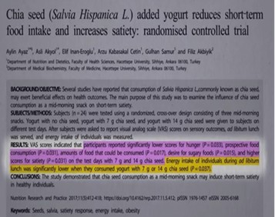

Participants were then allowed to eat as much as they wanted the rest of the day. The results were amazing

The yogurt alone group had no change in body weight .
The yogurt and 1 1 / 2 teaspoons of Chia seeds per day group ate 300 calories less per day
The yogurt and 3 teaspoons of Chia seeds group also ate 300 calories less per day.

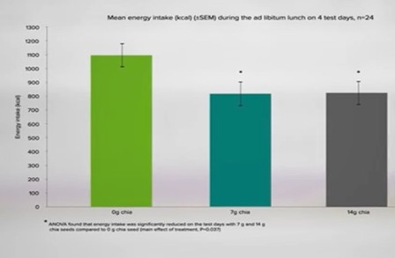

Studies show adding the Chia seeds appear to significantly increase satiety, decreasing calorie consumption, and may help you lose 7 pounds in 90 days. As i f that wasn’ t enough, they are a great source of f iber and omega-3 .

Try this simple trick to get more Chia Seed into your body.

TRICK #1 Add 1 ½ tsp Chia seeds to your f irst meal of the day to lose weight.

SHIFT YOUR EATING WINDOW
CHANGING THE TIME OF DAY YOU CONSUME
THE LARGEST PORTION OF YOUR CALORIES CAN HELP YOU LOSE 2 LBS IN A WEEK!

It is truly amazing how much the time of day that you consume calories affects your weight. Our bodies are built to burn more calories i f they are consumed
earlier in the day. In this f irst study, participants were divided into two groups. They each consumed a single meal consisting of 2000 calories ( not something I recommend).

Group one consumed 2000 cal for breakfast Group two consumed 2000 cal for supper

At the end of one week the group consuming their calories for breakfast had lost almost 3 pounds while the weight of group consuming calories late, remained
the same weight.
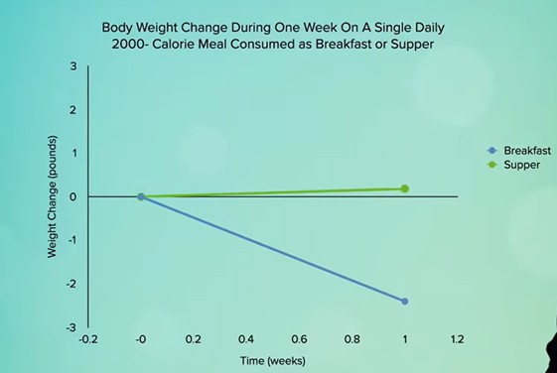

In a second study, participants ate three meals per day with equal calories. One group ate more calories earlier in the day and the other consumed more calories late in the day. The results were significant. The group consuming more calories earlier in the day lost 19 pounds total, while the group consuming more calories later in the day lost only 8 pounds:

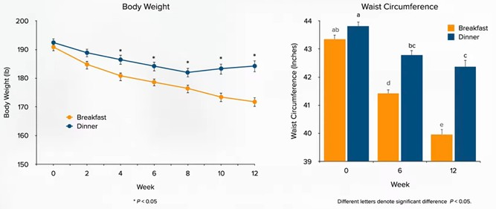

Evan more amazing was the early calorie group also lost an extra 2 inches off their waist ( the hardest place to lose weight).

The conclusion of the study: “ high calorie breakfast with reduced intake at dinner is beneficial and might be a useful alternative for the management of obesity.”

Try this simple trick to maximize the calorie burning in your body.

TRICK #2 Shift more of your calories to earlier in the day to lose weight.

CHEW YOUR FOOD
PAYING ATTENTION TO CHEW YOUR FOOD MORE THOROUGHLY WILL RESULT IN MAKING YOU EAT 12 % LESS!

Remember hearing this from your mother? Up to one third of digestion occurs in your mouth. Thorough chewing is something we should all do, but can it
help you lose weight? A study in the Science Direct Journal gave us the answer:
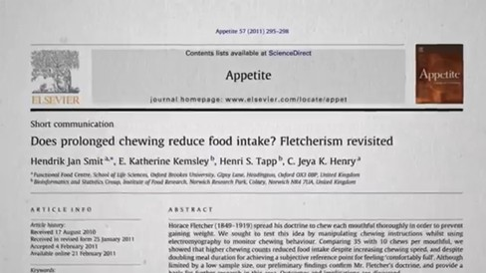

Participants were divided into two groups. The f irst group was instructed to
chew their food 10 times, the second group 35 times. They were then instructed to eat until they were full.

The group that chewed more ended up eating 12 % less!

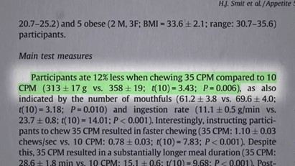

Try this simple trick to make sure you are chewing your food thoroughly. Count the number of times you chew each bite in your next meal.

TRICK #3 Chew your food at least 20 times to lose weight.

APPLE CIDER VINEGAR
ACTIVTE FAT BURNING BY JUST ADDING A LITTLE
APPLE CIDER VINEGAR AND LOSE 5 LBS IN 12 WEEKS!

Apple cider vinegar has been reported to be a weight loss aid since 1820.

In addition to weight loss, many other health claims have been touted by people using apple cider vinegar. The good news is, it is safe to use and there are only 3 calories per tablespoon, but does it really work for weight loss?

Apple cider vinegar has something in it called acetic acid. There are 4 g of acetic acid per milliliter of apple cider vinegar.

Studies show acetic acid in vinegar activates something in your body called
AMPK, which regulates energy balance at a cellular and whole-body level. Simply put, AMPK tells your body to stop storing fat and start burning it.

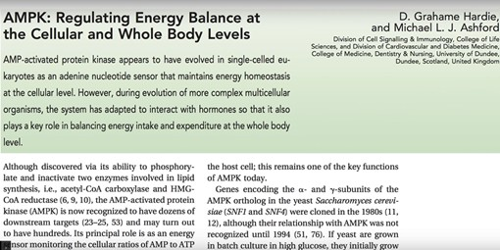

One of the f irst studies to prove its effectiveness was a 12 -week study where participants were divided into three groups, each group consuming the same number of calories per day:
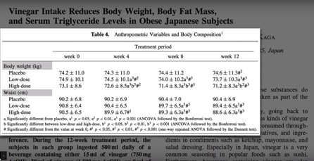

- No vinegar
- 1 tablespoon per day of apple cider vinegar
- 2 tablespoons per day of apple cider vinegar.

After 12 weeks:

The control group gained weight
  - tablespoon per day lost some weight
  - tablespoons per day dropped 5 pounds in 12 weeks. They also lost one inch off their waist!

This is significant because belly fat is one of the hardest areas to lose weight.
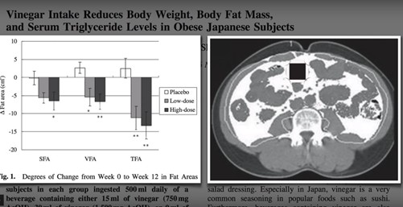

Try this simple trick to get more apple cider vinegar into your body:

TRICK #4 Use 2 tablespoons of apple cider vinegar per day. Do not take it without diluting it in water or you can add it on your salad.

ACTVATE THE FIAF HORMONE
ADDING PROBIOTICS WITH B 420 ACTIVATES THE
FIAF ( FASTING INDUCED ADIPOSE FACTOR)
HORMONE AND MAKES YOU SIGNIFICANTLY LESS HUNGRY – HELPING YOU DECREASE AT LEAST 300 CALORIES PER DAY!
While we’ re fasting our body has to stop storing fat and instead start burning it. FIAF-fasting induced adipose factor is one of the hormones that signals your body to make this happen. It Is produced by cells in the Digestive System and it tells
your body to burn fat because there is no food coming in.

Wouldn’ t it be wonderful i f there was a way to activate this hormone without fasting?

Now there is!

We now know that a few key gut bacteria are known to activate this hormone. These good gut bacteria can help you lose significant amounts of weight.

Here is how it works.
Studies show that certain good bacteria produce short chain fatty acids which up regulate the hormone FIAF. We also know that bad bacteria can repress FIAF
causing you to gain weight:

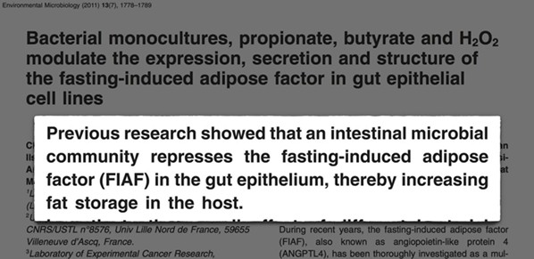

This has been confirmed by studies on people placed on antibiotics. Because antibiotics kill all of the good bacteria, it is no surprise that studies show
antibiotic use can significantly increase weight gain:
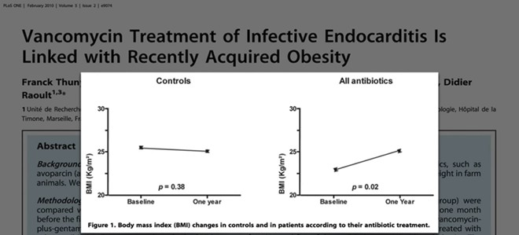

So how do you get these good bacteria into your Digestive System to activate
FIAF? One way would be to have a fecal transplant from a lean donor. Yes, that means taking someone’ s poo and putting it in you. This might not be appealing to many however:

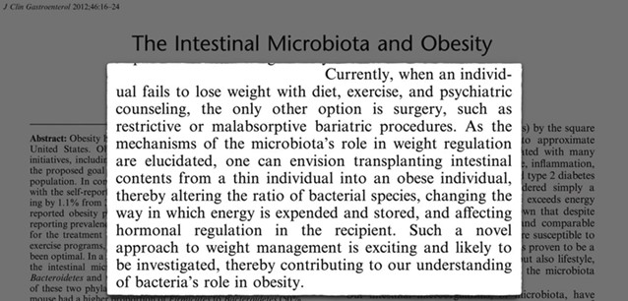

A simpler, effective way is to use a probiotic that contains B 420. In a six-
month human study, it has been shown to make people less hungry. So much so that they ate 300 calories less per day and lost an inch off their waist.

Try this simple trick to activate the FIAF hormone in your body:

TRICK #5 Make sure that you take a probiotic with B 420 to activate the FIAF.

- THE END -

Dear Reader,

There you have it – 5 easy and simple tricks that can kick start your weight loss and trick your body into burning more calories while reducing hunger.

If you’ d l ike more information on the 7-Systems whole-body plan or any of the supplements mentioned here – be sure to check out my website:

https://myrosechiro.com

Go to the 7 systems tab and watch the 5 minute video on how this plan has changed the lives of so many Nebraskans like you. We would love to help you wherever you may be on your journey!

For Your Health,
Dr. Jo Rose

